Subject 11

left right NFLI

0.450 0.472 2.410 di-word

0.489 0.383 -12.102 gi-nonword

0.428 0.428 0.000 hum

0.494 0.472 -2.299 tone

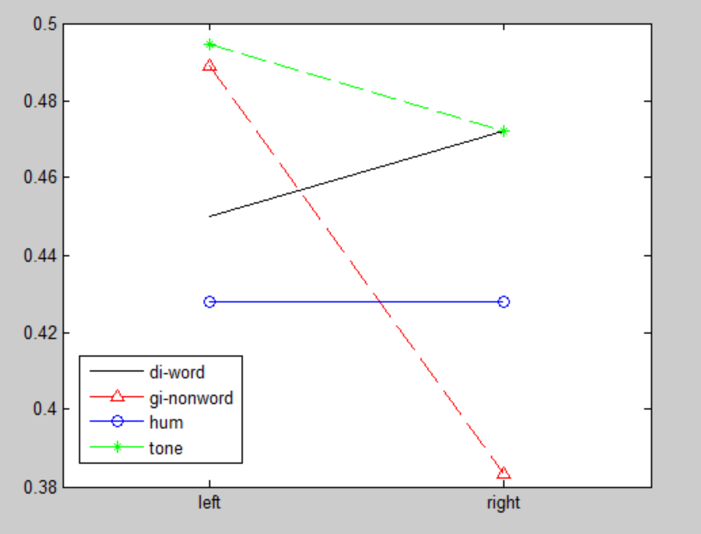

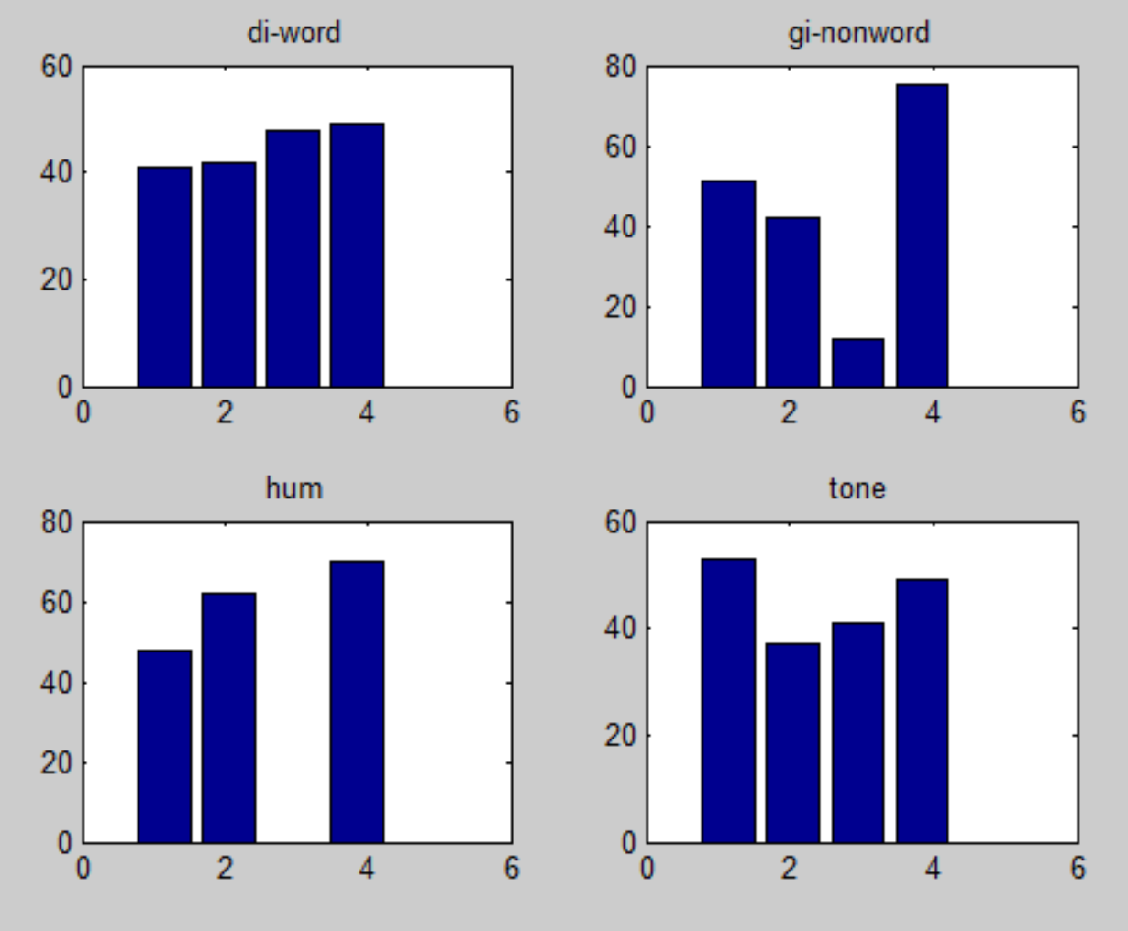

Subject 12

left right NFLI

0.361 0.444 10.345 di-word

0.394 0.417 2.740 gi-nonword

0.472 0.322 -18.881 hum

0.461 0.511 5.143 tone

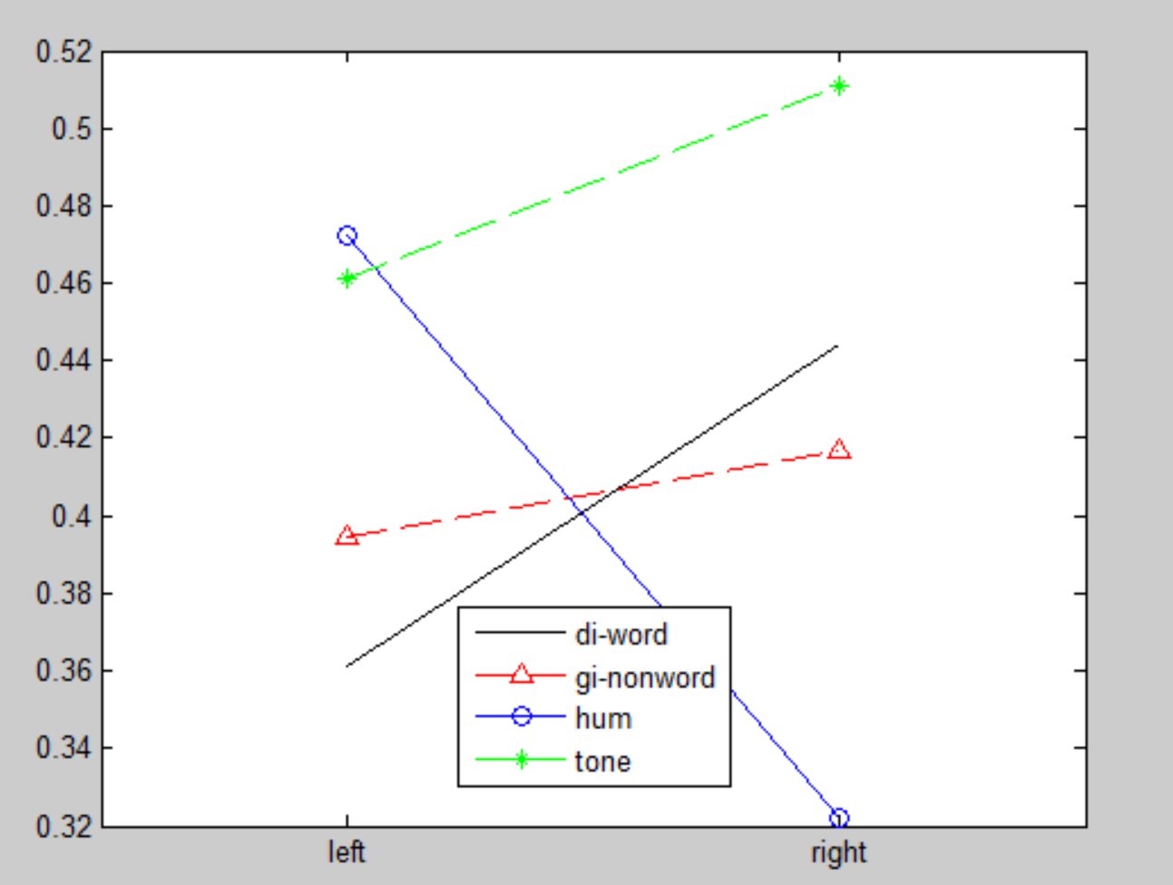

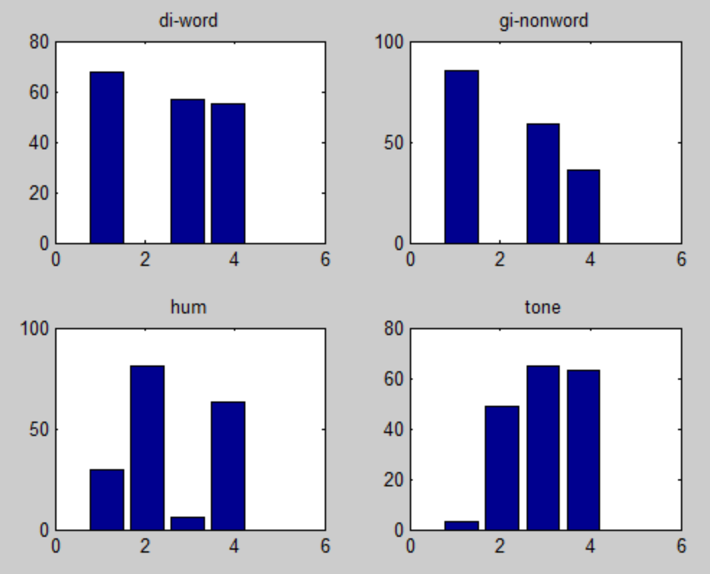

Subject 13

left right NFLI

0.450 0.306 -19.118 di-word

0.428 0.411 -1.987 gi-nonword

0.406 0.389 -2.098 hum

0.406 0.494 9.877 tone

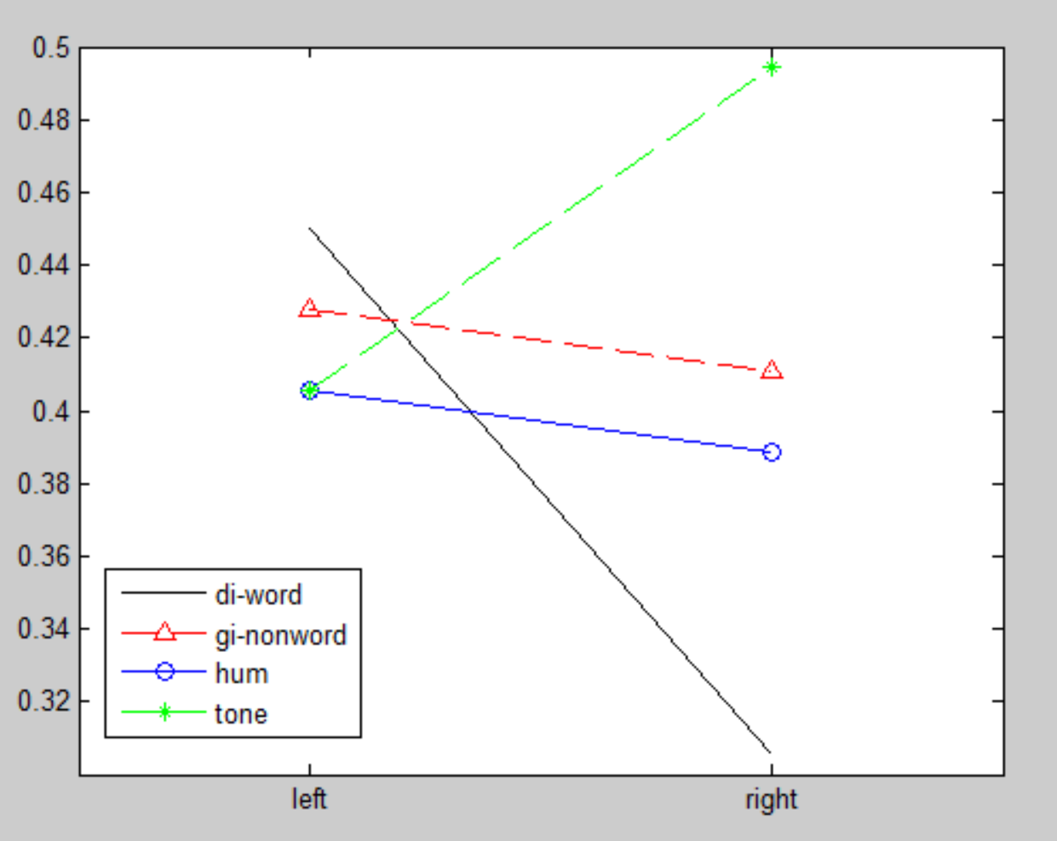

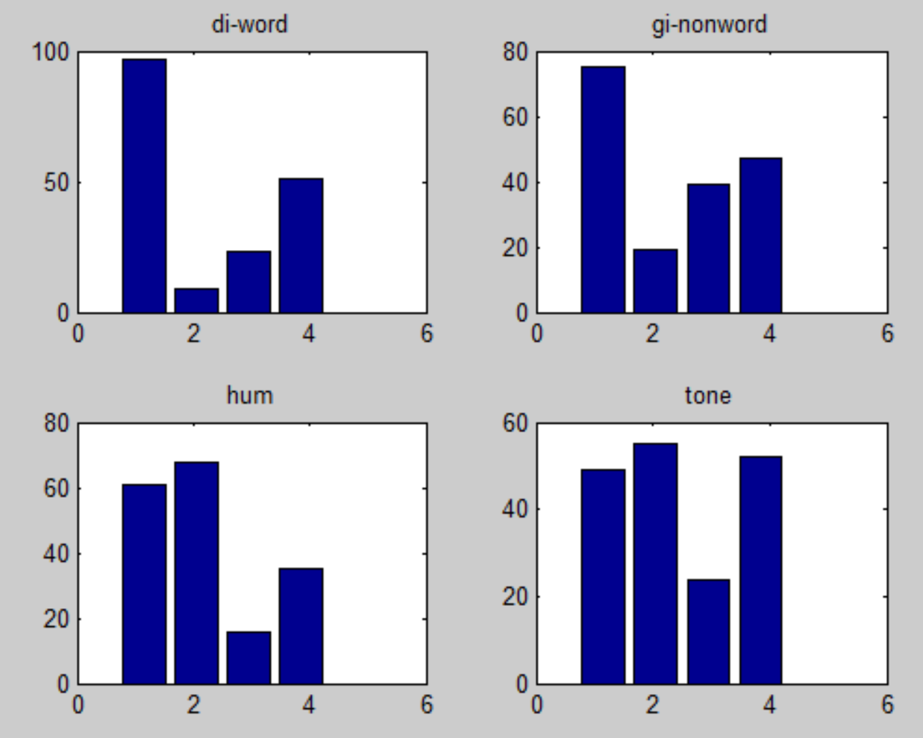

Subject 14

left right NFLI

0.567 0.328 -26.708 di-word

0.456 0.417 -4.459 gi-nonword

0.489 0.456 -3.529 hum

0.506 0.456 -5.202 tone

